**The One Page Data and Analytics Templates**

**Master Data and Analytics reports and processes with five templates**

**Introduction**

The best advice I got early in my career was to create templates for any reporting and development process.

Although initially, I found the template creation time-consuming, this step in pre-development and pre-planning saved tons of my time in later work.

And this is the knowledge that, nowadays, I try to transfer to all my colleagues and team members.

There are three main reasons why I template Data and Analytics reports and processes:

#1: ***Reusability —*** *templates can be reused and adapted to various data projects and processes.*

* *As a data lead, you can save time by creating templates for recurrent reports and scalable processes. This can include various templates — from stakeholders’ reports on the team’s development progress to the internal team’s meeting notes and development/testing processes.*
* *As a data professional, you can get more efficient when creating developer/end-user documentation once you already have predefined templates for summarizing development methodology and analytical insights.*

#2: ***Accuracy*** — *templates can ensure that the data reports and processes contain all relevant information for the organization and the data team.*

* *By templating the team’s development updates, you can minimize reporting errors and ensure easy cross-organizational and inter-team tracking of all necessary information.*

#3: ***Uniformity —*** *templates can ensure consistency and clarity of the data processes and insights.*

* *With predefined data templates, your stakeholders will get used to the existing documentation structure and quickly find the needed information, even in the newly documented processes and insights.*

With these three key points on why you should template the Data and Analytics processes and reports, I’ve put together a set of templates you can use in your data team and organization.

**The templates**

The below-listed Data and Analytics templates are used for team organization and sharing development updates. For each template, I will list the background story (reason for the development) and the scope of usage.

**#1: Data and Analytics roadmap template: The Effort-value matrix**

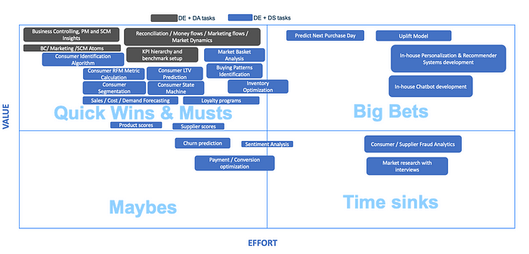

Data and Analytics roadmap template [Image by author]

***Background story:***

The template was created at the bare [establishment of the Data and Analytics team](https://medium.com/towards-data-science/3-animated-movie-quotes-to-follow-when-establishing-a-data-analytics-team-e7fd84357d84). Its purpose was to share and maintain a clear data and analytics vision, which had to be aligned with the organizational vision of becoming a data-driven company.

Hence, a Data and Analytics roadmap was created with planned use cases per different areas (data engineering, data analysis and data science) mapped within the effort-value matrix ([Eisenhower Matrix](https://thedecisionlab.com/reference-guide/management/the-eisenhower-matrix)).

The presented template had development versions, i.e., as the data use cases’ priorities evolved, the template evolved too.

***Scope of usage:***

The developed template for the Data and Analytics roadmap serves as an orientation of the development priorities or “quick wins” in the Data and Analytics team.

The template is also used for the structured and planned growth of the Data and Analytics team, as we know which workforce capacity is needed for the next stage of the roadmap delivery.

In addition, the template serves the business leads to easily follow the stages of the analytical development based on the prioritized business use cases.

**#2: Data and Analytics retro meeting template: Weekly inter-team reporting**

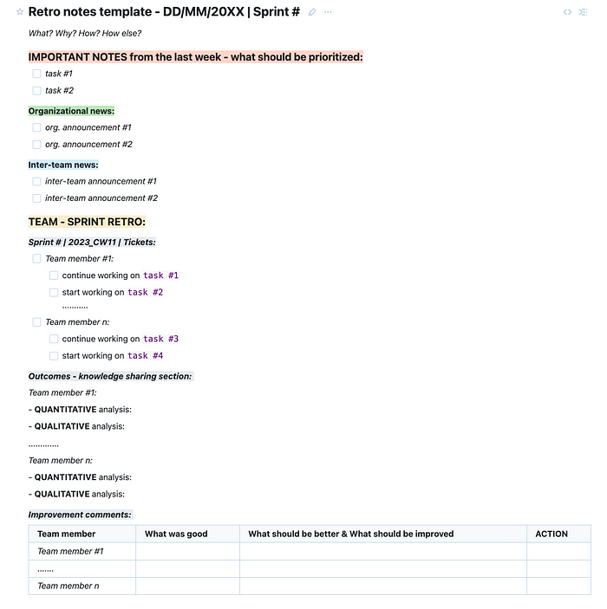

Data and Analytics retro meeting notes template [Image by author]

***Background story:***

The Data and Analytics weekly retro team meetings template was created to standardize the cross-organizational and inter-team announcements and reports on the team’s [Sprint](https://www.scrum.org/resources/what-is-a-sprint-in-scrum) tasks.

Besides improving inter-team communication, the template aimed to ensure information and work transparency in the specific data area.

***Scope of usage:***

Except for the eased communication, the template is used for the data lead to track the team’s progress and identify the areas that need improvement. With the structured way of reporting, it is easy to compare notes across different weeks and identify trends over time.

For the team members, the template encourages reflection on their work. Furthermore, it provides the necessary information, and knowledge exchange, on the work done by their colleagues (quantitative and qualitative descriptions of the tasks started/concluded).

**#3: Data and Analytics development documentation template: Documentation templates for explaining the development and end-user insights**

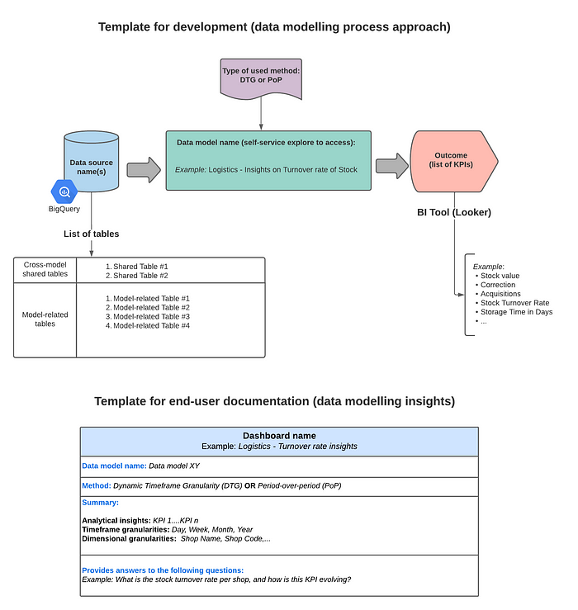

Data and Analytics development and end-user documentation template [Image by author]

***Background story:***

The goals for creating development and end-user documentation template were to improve the team’s efficiency (spend less time on documentation structuring) and provide more context to end users by explaining the data insights in a structured way.

***Scope of usage:***

Data Analysts/Scientists use the development documentation template to explain the data modelling process in a structured way, i.e. the *input* → *output* flow.

The end-user documentation template is used by stakeholders to quickly find the explanations of the newly created data insights (dashboards and reports). Hence, the end-user documentation is structured to elaborate the main dashboard elements: underlying data model, timeframe method, analytical summary, and which business questions the dashboard is answering.

**#4: Data and Analytics status update template: Monthly stakeholder reporting**

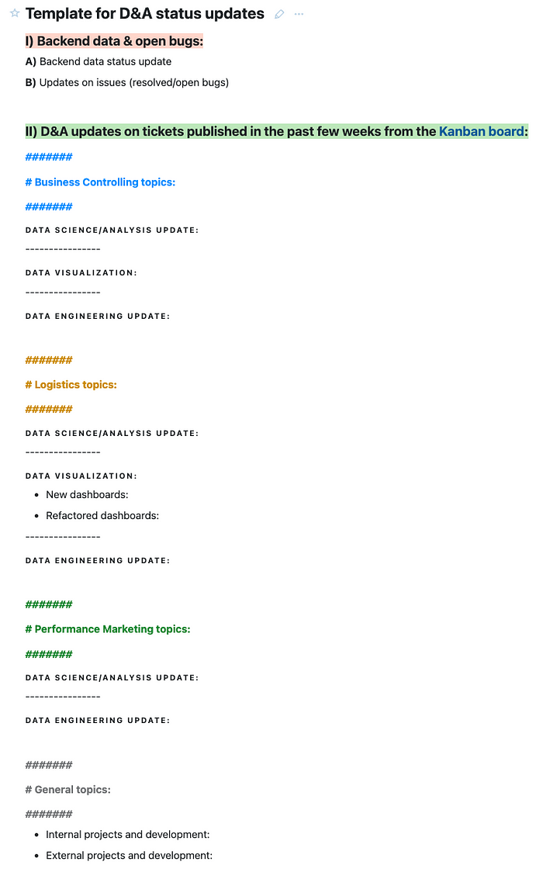

Data and Analytics monthly status update template [Image by author]

***Background story:***

The Data and Analytics monthly status update template was created to summarize the development updates per different business areas (business controlling, logistics, performance marketing) to all the stakeholders in the company.

***Scope of usage:***

The data lead uses the template to brief the CEOs and organizational leaders in a simple and structured way on the Data and Analytics team’s achievements.

In addition, the stakeholders are using the template to plan the business actions on the new data development.

**#5: Data and Analytics End-of-Year reporting template: Development highlights**

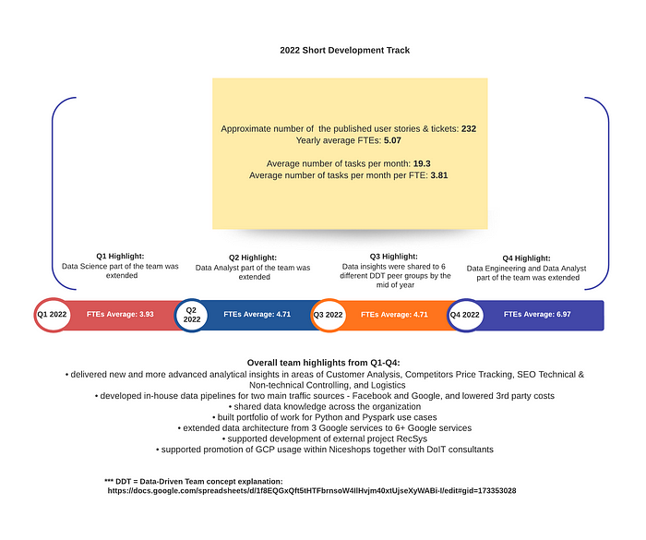

Data and Analytics End-of-Year reporting template [Image by author]

***Background story:***

The End-of-Year Data and Analytics reporting template was created to highlight yearly team growth and development.

***Scope of usage:***

The data lead uses the template to brief the CEOs and organizational leaders in a simple and structured way on the Data and Analytics team’s achievements.

In addition, this one-page report template can be used to make development plans for the upcoming year and present future data projects.

**Conclusion**

This blog post aimed to show the five one-page Data and Analytics templates that can be used in any organization by the data team/data leads or data stakeholders to improve the reporting quality, information sharing and team effectiveness.